I wanted to challenge myself with a new dataset, so I chose the CIFAR(10) dataset. I’ve also added the script in my Github, so you can see how I apply my logic throughout the script. I started off by implementing a simple baseline model to ensure proper training, tuning and logging. Baseline model has poor accuracy (as would be expected), 0.3594* after 5 epochs. (*Note added later: I noticed in my later runs that my outcomes were not deterministic, so I implemented a fixed seed to ensure proper testing from there on out. This is why the value of the screenshot is different from my table below)
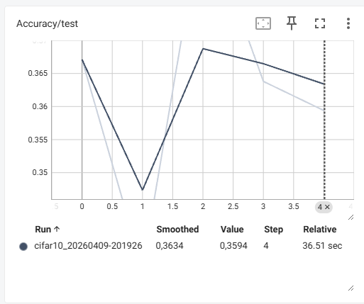
My hypothesis is: Increasing the complexity of my model will improve classification accuracy on CIFAR-10, up to a point where performance flips due to overfitting.
I’ve done various improvements, I’ve added a table below that shows the results per improvement.
Model | Improvement | Accuracy | Comments
Baseline | None, baseline model. | 0.3829 | Epochs = 5
Improved_v1 | Conv2d model | 0.3966 | Still linear
Improved_v2 | Conv2d non linear | 0.5587 | Added ReLU
Improved_v3 | Raised hidden units to 32 (doubled) | 0.5969
Improved_v4 | Added a layer | 0.6297 | Learning curve still steep, so will increase epochs
Improved_v5 | Increased epochs to 10 | 0.6049 | Accuracy actually decreased, I will add pooling now
Improved_v6 | Added pooling | 0.6675 | Epochs to 5 again for a bit faster training
Improved_v7 | Epochs to 10 again to see if it helps… | 0.6823
Improved_v8 | Added dropout | 0.6525
Improved_v9 | Added another layer | 0.6998
Improved_v10 | Added BatchNorm | 0.6289 | Steady increase until last epoch, then a massive dip from 0.7085 to 0.6289. Overall over the epochs, accuracy improved so improvement seem to have been useful. I will continue training for now with different improvements but will keep this in mind.
Improved_v11 | Increased amount of channels | 0.7743 | Training seems stable now.
Improved_v12 | Adding classifier head (before final classification) | 0.7785 | One run had 0.7924
Improved_v13 | Added random horizontal flip to training | 0.7745
Improved_v14 | Added random crop | 0.7745 | Other epochs had different accuracy, so seems like a coincidence that accuracy is the same
Improved_v15 | Increased epochs to 20 | 0.7731 | But training loss improved nice and steady. Model seems to be quite stable at this point.

The readme shows that there was a 18% test error. My model reached 77.31% accuracy, which I think comes close already to the mentioned test error with optimal hyperparameter tuning. Below I’ve added the curves of training as visualized via TensorBoard.
